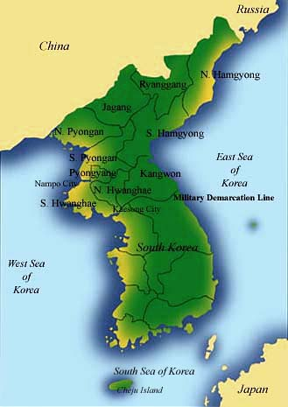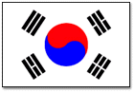
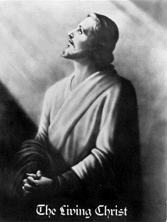

- Mathew 21:33-34 states it will not be Israel.
Instead Rev 7:2, an angel ascending
from the East = the Orient!
- Korea is a country with strong Christian traditions Billy Graham, Yonggi Cho...others have witnessed to.
- Korea is a country with heavenly traditions.
- A country who never started war in 4300 years.
- Many Messianic prophecies.
- Similar suffering history as Israel.
- 38th parallel is dividing good/evil.
- The country has a shape as an angel blowing a horn
Rev 7.
- The Korean language “Hangul” was received
through a revelation.
- The national dress is white cloth =Gods pure color.
- Korean houses have many spiritual symbols.
- The Korean flag is filled with symbols! - I Ching.
- The people has distinctive strong character.
- The country distinctive strong climate.
Very Cold winters - Very Hot summers!
- Most of the traditions has come through revelations.
- References to the year 1920:
  - 1920 Hitler started his movement on the same day Sun Myung Moon was born.
  - 1920 Lenin marches into Archangelsk with his communist army, 3 days before Sun Myung Moon was born. 3 = separation from satan
  - 1920 the Irish poet and Nobel winner Yeats writes a poem called the Second Coming.
  - 1936 Billy Grahams wife Ruth, grow up in China, just a few kilometers from the village in Korea where the 15 year young Korean boy Sun Myung Moon receive his great Mission directly from Jesus.

More about True Parents, their UNITED NATION vision for World Peace
http://www.euro-tongil.org/finnish/

www.euro-tongil.org/finnish

www.euro-tongil.org/finnish

www.euro-tongil.org/finnish

www.euro-tongil.org/finnish

www.euro-tongil.org/finnish

www.euro-tongil.org/finnish

www.euro-tongil.org/finnish

www.euro-tongil.org/finnish

www.euro-tongil.org/finnish

www.euro-tongil.org/finnish

www.euro-tongil.org/finnish

www.euro-tongil.org/finnish

www.euro-tongil.org/finnish

www.euro-tongil.org/finnish

www.euro-tongil.org/finnish

www.euro-tongil.org/finnish

www.euro-tongil.org/finnish

www.euro-tongil.org/finnish

www.euro-tongil.org/finnish

www.euro-tongil.org/finnish

www.euro-tongil.org/finnish

