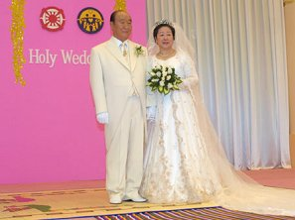
6 Febr 2003
True Parents and their
Vision for World Peace
www.euro-tongil.org/finnish

6 Febr 2003
True Parents and their
Vision for World Peace
www.euro-tongil.org/finnish

6 Febr 2003
True Parents and their
Vision for World Peace
www.euro-tongil.org/finnish

6 Febr 2003
True Parents and their
Vision for World Peace
www.euro-tongil.org/finnish

6 Febr 2003
True Parents and their
Vision for World Peace
www.euro-tongil.org/finnish

6 Febr 2003
True Parents and their
Vision for World Peace
www.euro-tongil.org/finnish
6 Febr 2003
True Parents and their
Vision for World Peace
www.euro-tongil.org/finnish

6 Febr 2003
True Parents and their
Vision for World Peace
www.euro-tongil.org/finnish

6 Febr 2003
True Parents and their
Vision for World Peace
www.euro-tongil.org/finnish

6 Febr 2003
True Parents and their
Vision for World Peace
www.euro-tongil.org/finnish

6 Febr 2003
True Parents and their
Vision for World Peace
www.euro-tongil.org/finnish

6 Febr 2003
True Parents and their
Vision for World Peace
www.euro-tongil.org/finnish

