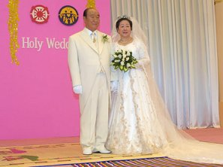
After 2000 years
The Return of Christ
6 Febr 2003
Rev 19:7
More about True Parents,
their vision for World Peace
www.euro-tongil.org/finnish

After 2000 years
The Return of Christ
6 Febr 2003
Rev 19:7
More about True Parents,
their vision for World Peace
www.euro-tongil.org/finnish

After 2000 years
The Return of Christ
6 Febr 2003
Rev 19:7
More about True Parents,
their vision for World Peace
www.euro-tongil.org/finnish

After 2000 years
The Return of Christ
6 Febr 2003
Rev 19:7
More about True Parents,
their vision for World Peace
www.euro-tongil.org/finnish

After 2000 years
The Return of Christ
6 Febr 2003
Rev 19:7
More about True Parents,
their vision for World Peace
www.euro-tongil.org/finnish

After 2000 years
The Return of Christ
6 Febr 2003
Rev 19:7
More about True Parents,
their vision for World Peace
www.euro-tongil.org/finnish

After 2000 years
The Return of Christ
6 Febr 2003
Rev 19:7
More about True Parents,
their vision for World Peace
www.euro-tongil.org/finnish

After 2000 years
The Return of Christ
6 Febr 2003
Rev 19:7
More about True Parents,
their vision for World Peace
www.euro-tongil.org/finnish

After 2000 years
The Return of Christ
6 Febr 2003
Rev 19:7
More about True Parents,
their vision for World Peace
www.euro-tongil.org/finnish

