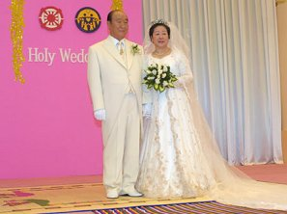
Marriage of he Lamb
6 Febr 2003
Rev 19:7
More about True Parents,
their vision for World Peace
www.euro-tongil.org/finnish

Marriage of he Lamb
6 Febr 2003
Rev 19:7
More about True Parents,
their vision for World Peace
www.euro-tongil.org/finnish

Marriage of he Lamb
6 Febr 2003
Rev 19:7
More about True Parents,
their vision for World Peace
www.euro-tongil.org/finnish

Marriage of he Lamb
6 Febr 2003
Rev 19:7
More about True Parents,
their vision for World Peace
www.euro-tongil.org/finnish

Marriage of he Lamb
6 Febr 2003
Rev 19:7
More about True Parents,
their vision for World Peace
www.euro-tongil.org/finnish

Marriage of he Lamb
6 Febr 2003
Rev 19:7
More about True Parents,
their vision for World Peace
www.euro-tongil.org/finnish

Marriage of he Lamb
6 Febr 2003
Rev 19:7
More about True Parents,
their vision for World Peace
www.euro-tongil.org/finnish

Marriage of he Lamb
6 Febr 2003
Rev 19:7
More about True Parents,
their vision for World Peace
www.euro-tongil.org/finnish

Marriage of he Lamb
6 Febr 2003
Rev 19:7
More about True Parents,
their vision for World Peace
www.euro-tongil.org/finnish

